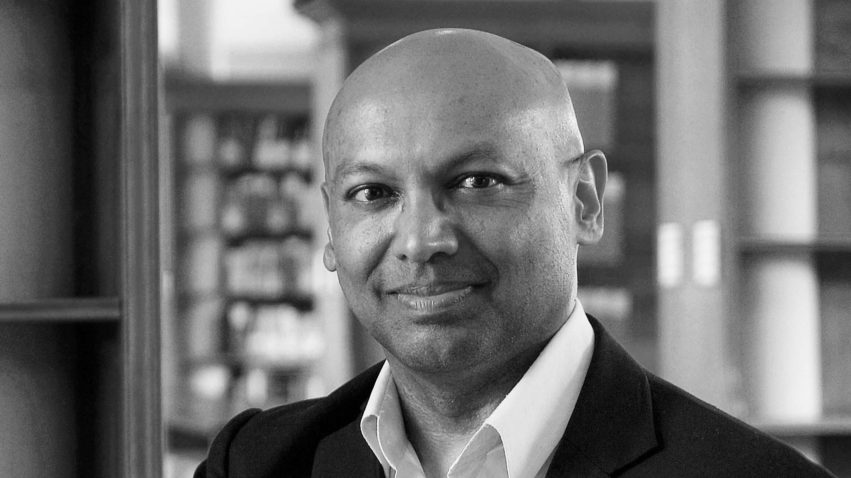
Dr Daryl L. Fernandes – Short Biography

Dr. Daryl Fernandes - Founder and Chief Executive of Ludger Ltd, Oxford, UK
Email: daryl.fernandes@ludger.com

Daryl has over twenty-eight years experience in developing and using glycoprofiling technology in medicine and biotechnology. He gained his doctorate in structural analysis of biological oligosaccharides at the Glycobiology Institute, University of Oxford in the 1980s, was a consultant on biopharmaceutical glycoprofiling to Monsanto and G.D. Searle and helped spin out Oxford GlycoSciences (OGS) from the University. OGS was the second high technology company to spin out of Oxford University and specialised in glycoanalysis products and services for biopharma. Daryl joined OGS in 1993 as Process Development Manager and then as the Head of Analytical Services.

In 1999 Daryl left OGS to set up his own bioscience company, Ludger. Ludger’s main aim is to provide useful, reliable and affordable glycoprofiling technology for biopharmaceutical companies. The company has laboratories at the Culham Science Centre near Oxford in the UK and develops technology to measure and control biopharmaceutical glycosylation throughout the drug life cycle. Ludger provides a range of glycoprofiling systems (as kits and reagents) and analytical services to biologics developers and manufacturers worldwide. It also helps developers of glycoprotein therapeutics – from originators of novel biopharmaceuticals to developers of biosimilars and biobetters - plan their glycosylation characterisation and comparability studies to support drug optimisation programmes and regulatory submissions.

Daryl's research interests include development of reliable, sensitive high throughput glycoprofiling technology for biopharmaceuticals and developing practical methods for lifecyle and brand-to-brand comparability of glycoprotein therapeutics that have complex, variable and microheterogeneous glycosylation.

When Daryl is not scribbling glycan structures and mindmaps on big pieces of paper he enjoys spending time with his wife Clare and little son Ruben (who loves helping with the gardening, seeing animals at the zoo, dancing, and lots and lots more).

